Atonometrics

A quick word about Word

If you compose your site’s text content in word processer like Ms Word, you will see some issues if you copy+paste it directly into Wordpress (or any webpage). Ms Word adds ‘invisible’ HTML code around its text, and when you paste all this into an environment that reads HTML, you will see your text formatted with Word’s HTML instead of your site’s HTML, or some weird combination of the two. Circumventing this is easy because Wordpress already thought of that!

On your edit page/post buttons bar, there is a button called “Paste as Plain Text”. Click it and a box will popup. Paste your text from Word in the box, click “insert”, and your content is safely pasted.
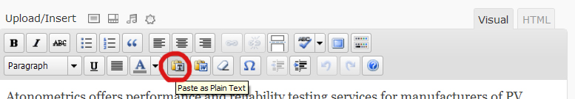

Changing the Homepage Hero Images/ Slides

Create new images that are either .jpg or .png images. The image dimensions should be 848px wide by 282px tall*. If your image editor has the option for image quality/ image file size, images ideally should be less than 50KB in size – this will help the page load faster, and the slider not lag.

Log in to your site; once you are in the “Dashboard” area, go to
Appearance > Widgets and click on the “homepage hero area” at the right.
There should be an item in that area called “PHP widget”.
If you expand it, you will see the code for the homepage hero.

Since the code is in such a small area, copy all of it (Ctrl + A, then Ctrl + C),
And then paste it in Notepad (PC) or TextEdit (Mac) so you can better work with it.

You will see something that looks similar to this:


You MUST use a plain text editor, not MS Word, or the code will get messed up (an HTML editor like Dreamweaver is also fine, but overkill for something like this).
If you copy and use the examples in this word doc, then the code will probably get messed up as well. Please do all of your code editing in a plain text editor.

Once you have made your code changes in a plain text editor, copy all of it, then delete all the code in the PHP widget area, and paste your new code in its place.

Slide Titles
The
<h2><span>CONTINUOUS SOLAR SIMULATION CHAMBERS</span></h2> are the titles on the vertical bars.

To change a title, change what corresponds to only the green text below
<h2><span>CONTINUOUS SOLAR SIMULATION CHAMBERS</span></h2>

Slide Content
The
<a href="/products/i-v-measurement-systems-for-pv-modules/"><img src="<?php bloginfo("template_url"); ?>/slider/Slide2.jpg" width="848" alt="image" /></a>
is the content of each slide.

The content consists of a link and an image, so you’ll need to change both to fully change the content.

Links
To change the link, overwrite what corresponds to only the green text below
<a href="/products/i-v-measurement-systems-for-pv-modules/"><img src="<?php bloginfo("template_url"); ?>/slider/Slide2.jpg" width="848" alt="image" /></a>

Links to pages within your site can leave off the ‘http://atonometrics.com’, or you can use the full url from the address bar of your browser. Links to outside pages should always use the full url.

If you want to have a slide that doesn’t link anywhere, delete all the link code:
<a href="/products/i-v-measurement-systems-for-pv-modules/"><img src="<?php bloginfo("template_url"); ?>/slider/Slide2.jpg" width="848" alt="image" /></a>

Images
To change the image, overwrite what corresponds to only the green text below
<a href="/products/i-v-measurement-systems-for-pv-modules/"><img src="<?php bloginfo("template_url"); ?>/slider/Slide2.jpg" width="848" alt="image" /></a>

This will be the path to your new banner image. You can upload your new image in the image upload dialogue of any page (just don’t click the ‘insert into post/page’ button), and copy the image url from there. Paste the whole url path where the green text is. Your url will probably look something like “http://atonometrics.com/wp-content/uploads/my-slide-title.jpg”

Slides
Each slide is all the code from <li> to </li>
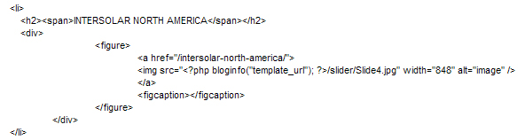
So if you want to delete a slide, delete from the <li> before the title, to the </li> further down after the slide content.

If you want to add a slide, copy an existing one from <li> to </li> and change the title and content.

*Number of Slides
You can have as many or as few slides as you want, though 3-6 is probably the most aesthetically pleasing.

Currently, the slide images are sized to fit perfectly with 4 title bars/slides. If you delete slides, you may see more horizontal spacing, and if you add slides, you may see them getting cut off. Here’s how to fix it:

Adding slides

If you add slides, you’ll see that at the current size, slides get cut off at the right. If this looks fine, then there isn’t a problem. If you want to fix it, you’ll need to decrease the width of the images. Try decreasing your image width by 30px for each additional slide you added (because the vertical title bars are about 30px wide each), but you may need to play around to get the width looking just right. The height should always be 282px tall. You’ll also need to change the width in the code, green here:
<a href="/products/i-v-measurement-systems-for-pv-modules/"><img src="<?php bloginfo("template_url"); ?>/slider/Slide2.jpg" width="780" alt="image" /></a>
You will need to resize all the images used in your slider.

Subtracting Slides

If you subtract slides, you’ll see more horizontal space. Depending on your slide content, you can fix this in two ways. You will need to resize all the images used in your slider.
- If your images have a lot of ‘unimportant’ room around the edges, you can just make them wider with the code, green here:
<a href="/products/i-v-measurement-systems-for-pv-modules/"><img src="<?php bloginfo("template_url"); ?>/slider/Slide2.jpg" width="910" alt="image" /></a>
This will make the whole image bigger, filling up the space. The edges will be cut off. If nothing important is cut off, this is an easy solution. I tried this method with the example slide, and it still looked good.
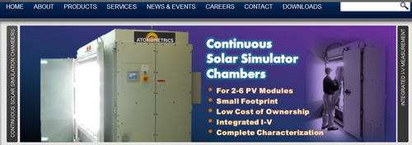
- If the first way is inappropriate for your slide images, then you’ll need to make your images wider. Try adding 30px to the image width for every slide you deleted, but again, you’ll probably need to play with that number to get it just right. The height should always be 282px tall. Also change the width in the code, green here:
<a href="/products/i-v-measurement-systems-for-pv-modules/"><img src="<?php bloginfo("template_url"); ?>/slider/Slide2.jpg" width="910" alt="image" /></a>

Advanced slide content
The content of each slide can be images and/or HTML/ text – this is a very versatile slider! More information and examples can be found here: http://nicolahibbert.com/demo/liteAccordion/.

Help, I broke the code!
There is an example of working code called homepage slider example.html. Should anything get messed up, you can always build from that. Open it with Notepad or Textpad. It is also a good idea to make a backup of the code before you change it (just in case!). When you paste code into a text editor to work with it, you can save a copy as a .txt or .html file.

Page Banners

There is a Photoshop template, page-banner-template.psd, that you can use to create page banners with rounded corners. If you can’t use this template (no Photoshop-compatible image editor for example), you can create .jpg or .png images that are 660px wide by 150px tall to fit in the page banner space.

Questions
If there is anything you feel uncomfortable doing, just let us know and we’ll fix it!

